STANDARD FORMAT OF “LEHENGA DESCRIPTION”


For Online Selling Products
Design Name: COSMIC-B
Product Colours NO.: B6

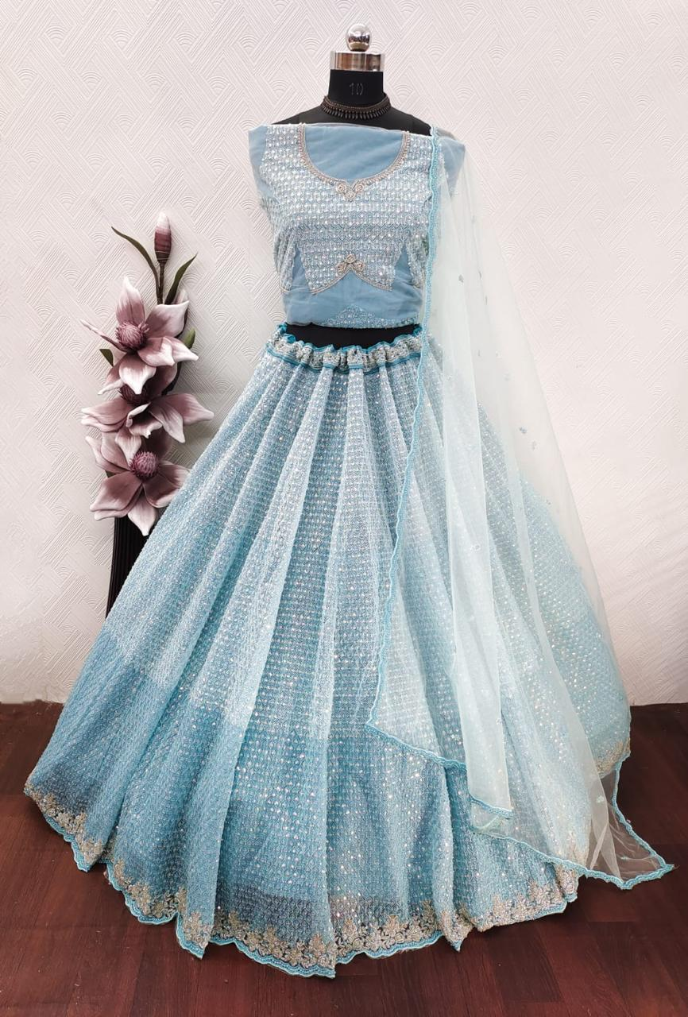
Particulars | Details
Lehenga Fabric | Net
Blouse Fabric | Net
Dupatta Fabric | Net
Work Type | Sequence & Beads
Colour | Sky-Blue
Pattern | Girlish
Stitching Type | Semi-Stitched (Can be customized up to 44")
Occasion | Reception, Festive Wear
Fit Type | Regular Fit
Care Instructions | Dry Clean Only
Package Contents | 1 Lehenga, 1 Blouse Piece, 1 Dupatta

KEY HIGHLIGHTS
- Made from premium net fabric, giving a lightweight and flowy appearance
- Decorated with sequence and beads work for a sparkling, glamorous look
- Designed in a stylish pattern, perfect for modern ethnic wear
- Semi-stitched design allows easy customization up to size 44
- Regular fit ensures comfort along with elegant drape
- Ideal choice for receptions and party occasions
- Easy maintenance with dry clean only care

